Chapter 9, Solution 64.

Find Z_{T} and I in the circuit shown in Fig. 9.71.
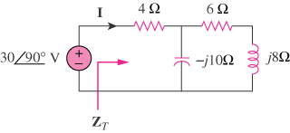

Figure 9.71
For Prob. 9.64.

Solution

Z_{T} = (19–j5) Ω

I = 1.527∠104.7° A

